**REST API Testing**

Contents

Summary 2

Reset the test data 3

Buy a quantity of each fuel 4

Verify that each order from the previous step is returned in the /orders list with the expected details 5

Confirm how many orders were created before the current date 7

Automate any other validation scenarios that you would consider writing for this API 8

Record and share any defects identified. 9

Single Previous order throw Internal Server error 9

Price of electricity is £0.47. in the API response price returned as 47.0 10

Order of elements in “Orders” response is inconsistent 11

Orders List - Fuel vale is inconsistent electric/Elec 12

# Summary

* Postman is used to automate the endpoints and validations. Please note a few scenarios/validations are covered as part of this exercise.
* “QA_Excercise” workspace is created with “Ensek” collection to cater “Buy more fuel” endpoints
* Collection and Global Variables are exported and placed in GITHUB
* Current folder structure is based on operation. Alternatively can be grouped by functionality or by requirements.

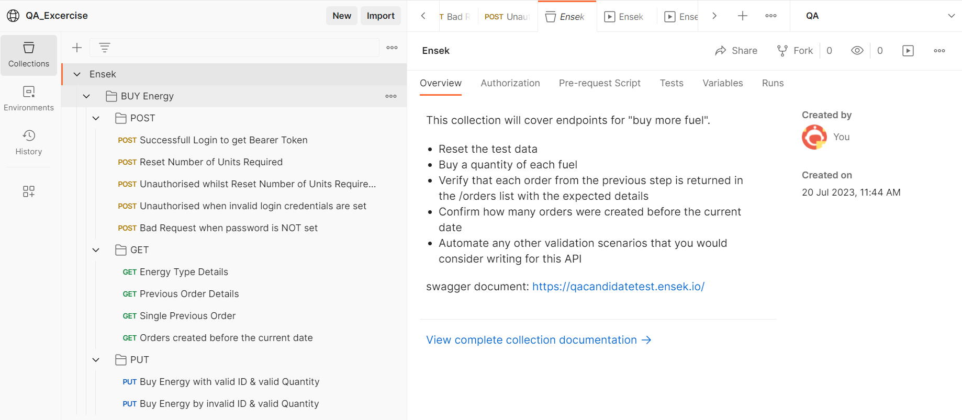

# Reset the test data

Below highlighted end points cover reset test data

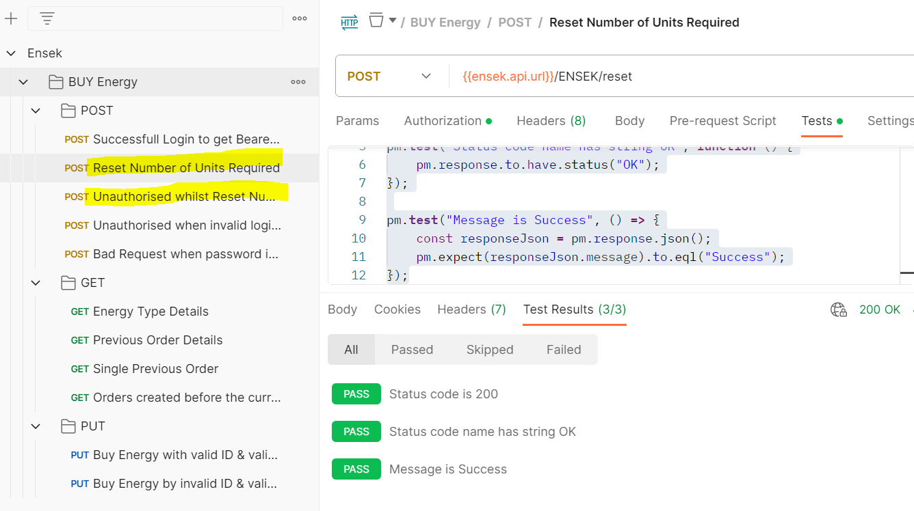

# Buy a quantity of each fuel

* Valid and invalid scenarios are written
* ID and Quantity can be parameterized in the endpoint URL i.e. {{ensek.api.url}}/ENSEK/buy/{{id}}/{{qty}}

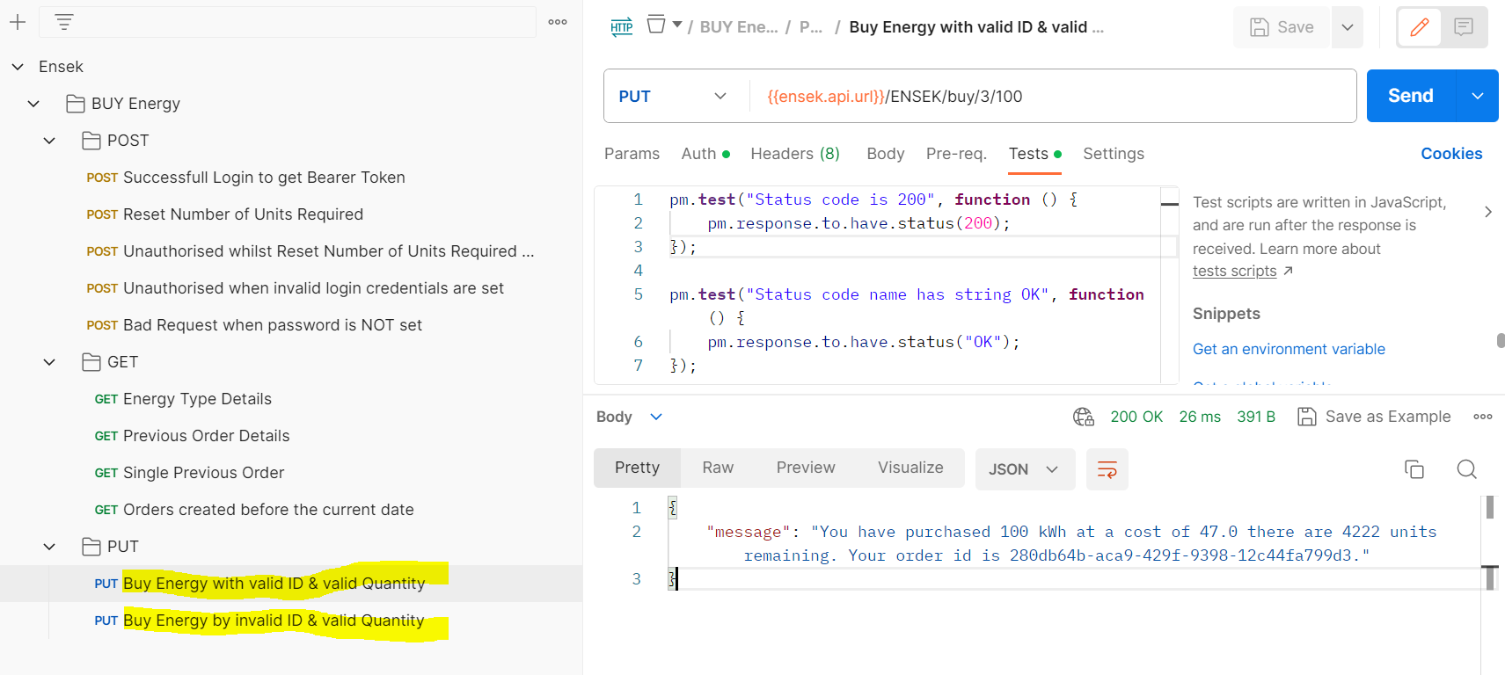

# Verify that each order from the previous step is returned in the /orders list with the expected details

* Validations are done on electric energy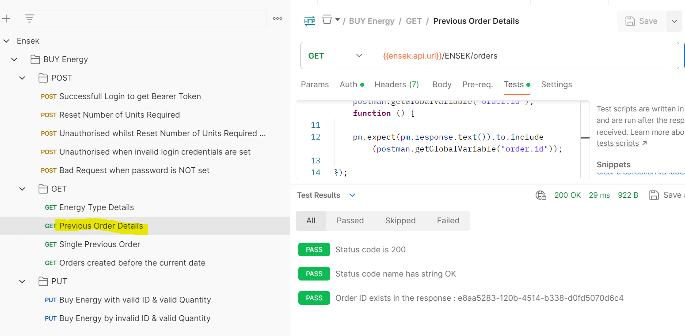y type

# Confirm how many orders were created before the current date

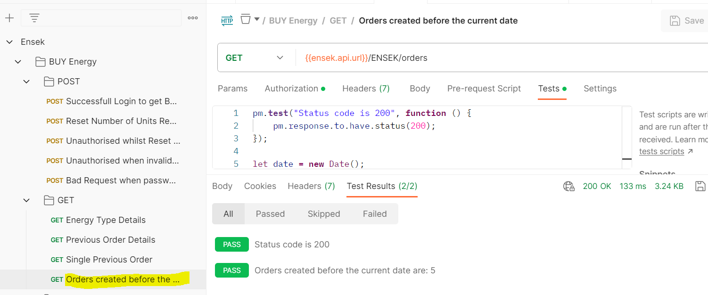

# Automate any other validation scenarios that you would consider writing for this API

* Json schema validation
* Data types in JSON response
* Rules violation in API definition

# Record and share any defects identified.

## Single Previous order throw Internal Server error.

**Note**: Same Internal server error exists with DELETE orders as well.

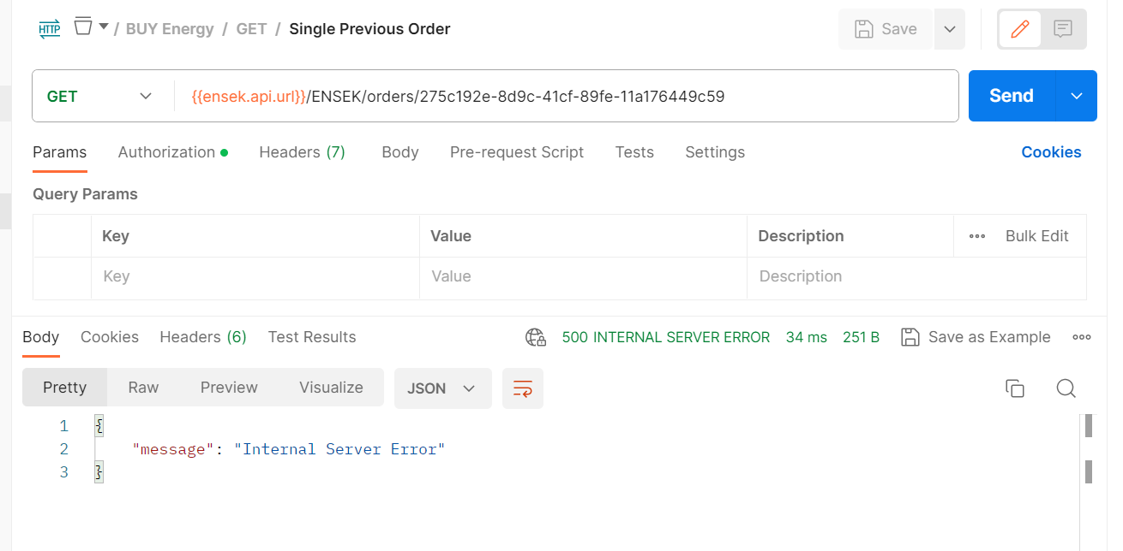

## Price of electricity is £0.47. in the API response price returned as 47.0

Message should be something below:

You have purchased 100 units at a cost of £0.47 per kWh and there are 4222 units remaining.

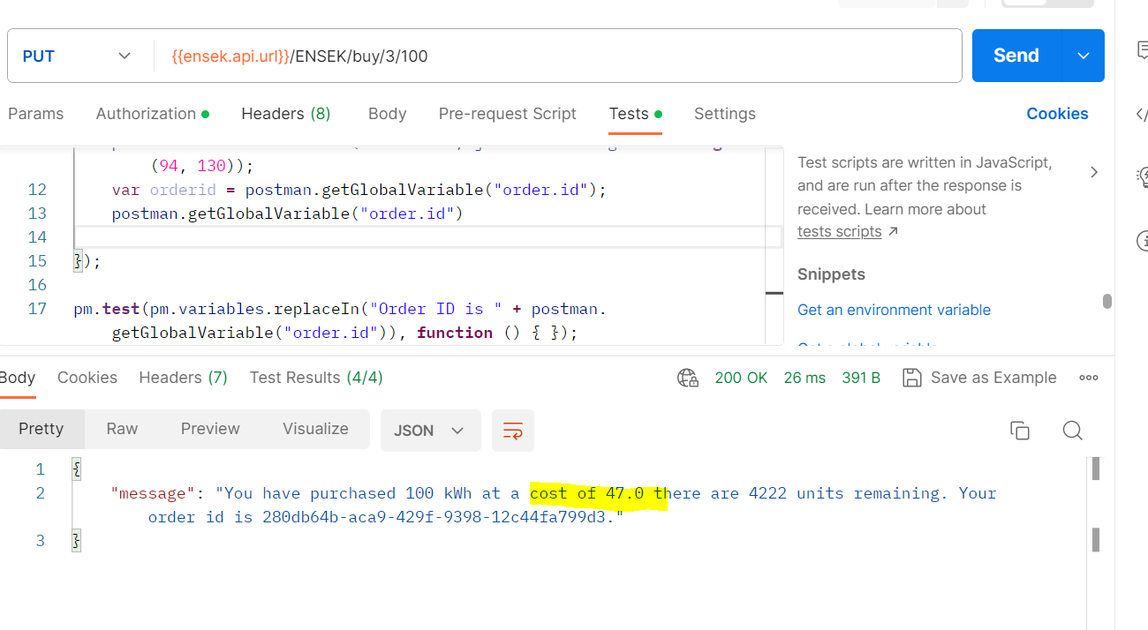

## Order of elements in “Orders” response is inconsistent

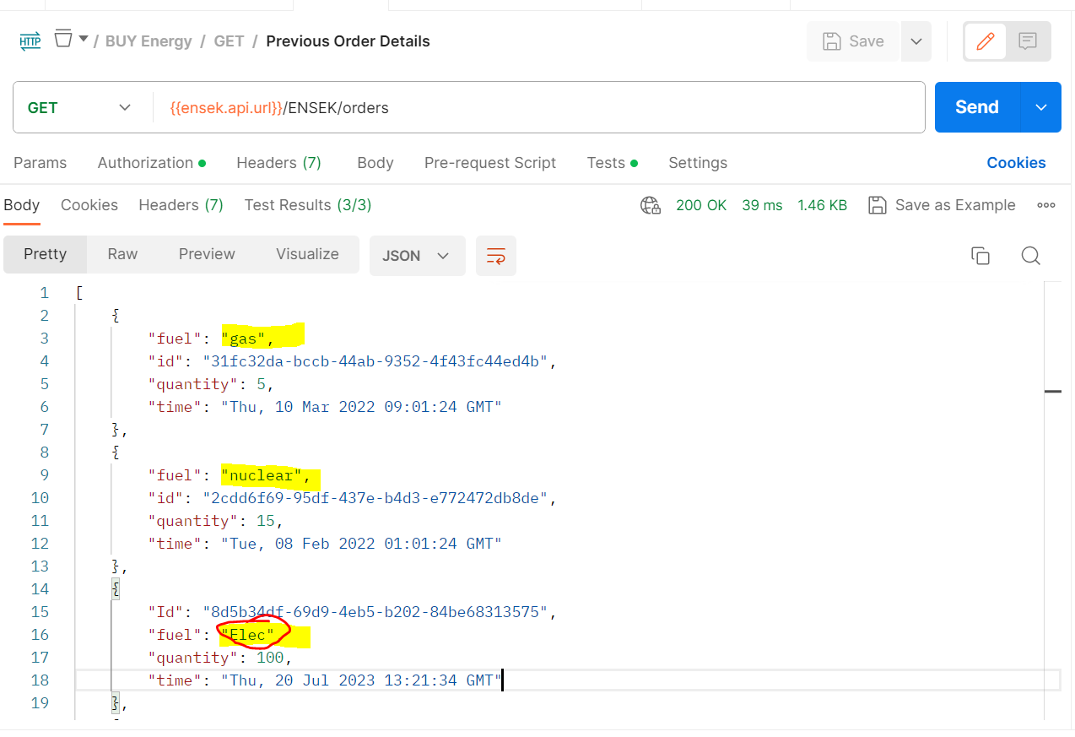

## Orders List - Fuel vale is inconsistent electric/Elec

